Load Tender Email Notifications
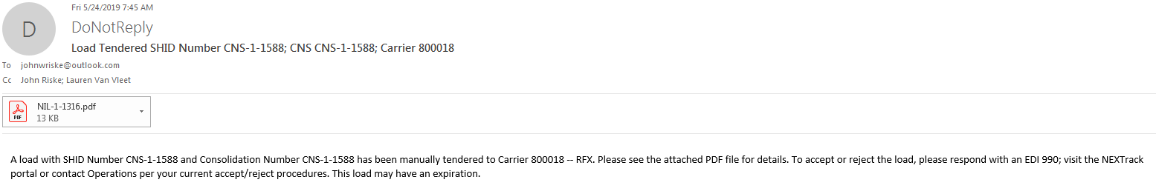

Load tender expired notification, sets status to N.
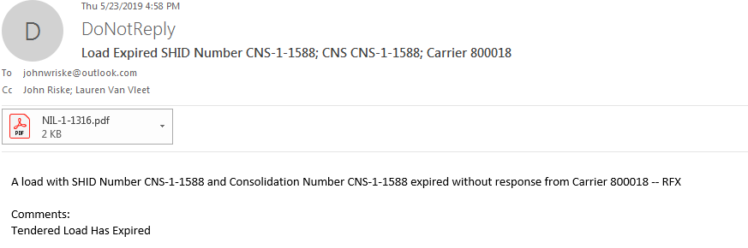

Load tender modification, when set to P status.
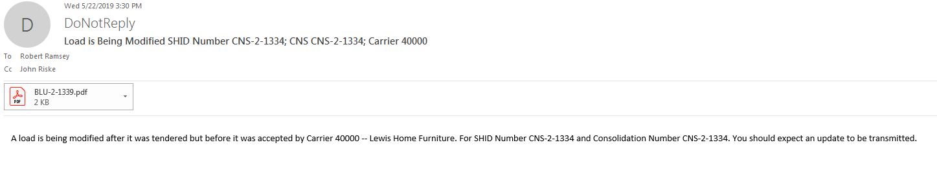
Note, when modified and set to P status, the carrier still assumes they’re getting the load. Be sure to communicate with carrier accordingly. This setting should not be used if your intention is to cancel the load with the carrier. You should use REJECT or Drop Load. This will set the status to N and send off and email indicating load was rejected/cancelled.

